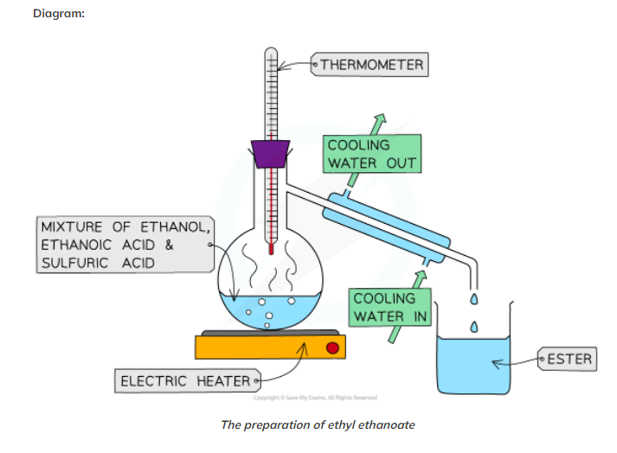

<https://www.savemyexams.co.uk/igcse/chemistry/edexcel/19/revision-notes/4-organic-chemistry/4-7-esters/4-7-2-practical-preparation-of-ethyl-ethanoate/>

VIDEO <https://www.youtube.com/watch?v=Gm9iysPq9ko>

